MedInGreen - Towards Green Economies in the Southern Neighbourhood

Terms of References

Practical guide - Environmental and social approach of the Med-In-Green project.

Sustainable Development Department
Urban development & Circular Economy Unit

March 2024

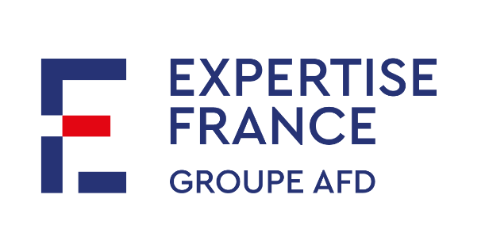
Table des matières

1. Summary 3
2. General information 3
2.1. Presentation of Expertise France 3
2.2. Description of the Project 4
2.3. Gender context and challenge 5
3. Description of the Consultancy 6
3.1. Objective of the consultance 6
3.2. Nature of the services requested 6
4. Methodology 7
4.1. Methodological guidelines 7
4.2. Interlocutor 8
4.3. Deliverables 8
4.4. Duration & indicative schedule 9
4.5. Budget 9
5. Skills and Experience 9
6. Application Modalities 9

Summary
Location: remote and potential travel to Jordan (Amman)
Duration: February to May 2024
Start of mission: 01/02/2024

General information

Presentation of Expertise France
Expertise France (EF) is a public agency and the interministerial actor in international technical cooperation. It became a subsidiary of the French Agency for Development Group (“Agence française de développement” in French / AFD Group) in January 2022. As the second largest agency in Europe, it designs and implements projects that sustainably strengthen public policies in developing and emerging countries on a range of policy issues (e.g. sustainable development, governance, stability, health, education).
It operates in key areas of development and contributes alongside its partners to the implementation of the Sustainable Development Goals (SDGs).
Democratic, economic and financial governance
Climate, biodiversity and sustainable development
Health & human development
Our sectors of operation
Peace, stability & security
EF supports, advises and trains national and local authorities in the definition and implementation of quality public policies adapted to the needs of the population. Focusing on the transfer of dialogue between peers, our interventions aim to strengthen the capacities of partner countries. We contribute to the emergence of innovative solutions adapted to the local context by bringing together the best know-how.
EF advises and supports partner institutions - central administrations, regional organisations, local authorities, civil society organisations, etc. - from the definition of their needs to the final evaluation of activities carried out. EF manages the administrative and financial aspects while ensuring the link with the donor and the partners. The M&E of activities, which is essential for assessing the effectiveness of interventions and identifying good practices, is also carried out by the project team. | 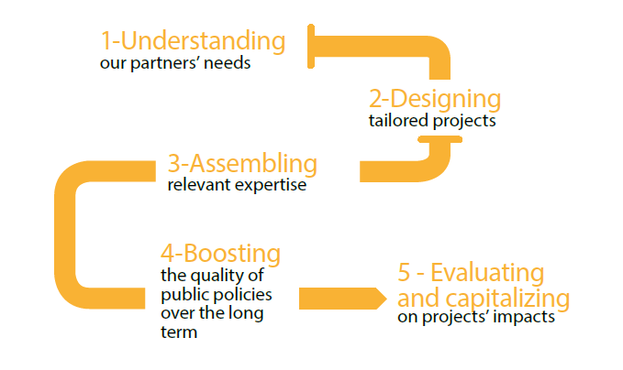
EF currently has over 500 projects under implementation in 100 countries, of which only 3% are currently in Asia. EF is working with a large number of donors such as the European Union (EU), AFD, the United Nations, etc. Expertise has more than 1000 staff working both in the headquarters in Paris and directly with the partners in the countries.

Expertise France's Sustainable Development Department (SDD)
The SDD is one of the 6 thematic departments of the agency. With currently 30 projects in operation and 10 in development, for a volume of activity of 29 M€ in 2021, EF's SDD supports its partners in the design and implementation of public policies in the fields of climate and territorial planning, access to urban services, energy, agriculture, and biodiversity.

Description of the Project
The European Union (DG NEAR) is going to finance the “Green and Circular Economy in the Southern Neighbourhood” programme to support the strengthening and promotion of the GCE as a vector for job creation and expansion of economic opportunities; while contributing to achieving the external dimension of the Green Deal in the Mediterranean and promoting European green standards. This action will focus on 3 levels of intervention: macro (policy framework), meso (institutions) and micro (enterprise) levels.
The regional layer will serve as catalyzer to mainstream ideas, stimulate peer competition, sharing EU expertise, and standardized messages and seize the “building back better” momentum.
Expertise France has been entrusted with the implementation of Component 1, named “MedInGreen” - Towards Green Economies in the Southern Neighbourhood. This 48-month project, with a total budget of 4 M€, will aim to promote, develop and strengthen sound policies and enforceable legislation for the promotion of inclusive GCE through advocacy and peer exchange and increase the level of collaboration between stakeholders.
Public policies are the foundation to the development of a cleaner and greener economy. In this context, MedInGreen will address the need to mainstream inclusive GCE’s objectives at a policy level. The project will also promote a policy convergence on GCE with EU policy framework and within the region.
The Specific objectives (Outcomes) of the project are:
- Outcome 1: Public authorities in the region share a common vision of inclusive GCE inspired by EU best practices.
- Outcome 2: Inclusive GCE principles, inspired by EU policies best practices, are mainstreamed in national policy and regulatory frameworks of the countries of the Southern neighborhood.
The targeted countries are of the project are:
- In North Africa: Algeria, Egypt, Libya, Morocco, and Tunisia;
- In the Middle East: Israel, Jordan, Lebanon and Palestine.

The Outputs to be delivered by this action contributing to the corresponding SO are:
- Contributing to SO 1
  - Output 1.1: Stakeholders at regional level are sensitised on GCE opportunities and informed about the Green Deal and other related EU initiatives.
  - Output 1.2: Policy dialogue is fostered at regional level between policy makers and EU counterparts.
  - Output 1.3: Good practices that comply with EU standards are shared among stakeholders (public authorities, private sector, civil society, research) at regional level.
- Contributing to SO 2
  - Output 2.1: Southern neighbourhood countries dispose of a roadmap to mainstream inclusive GCE in their policy and regulatory frameworks
  - Output 2.2: The countries are supported to improve their policy and regulatory frameworks based on selected priorities identified in the roadmap

Description of the Consultancy

Objective of the consultance
The objective of the consultancy is to support Expertise France in the analysis and consideration of social and environmental issues at project implementation level carrying out a Practical Guide to develop an environmental and social approach of the Med-In-Green project.
The practical Guide is designed to set out concisely in a single document the objectives, measures and actions required to ensure that the project complies with the main environmental and social protection standards recognised by the international community and used in international cooperation and is effective in applying these principles throughout the programme.
This guide, dedicated to the project team and all associated beneficiaries, is part of the project's inception phase and aims to develop an eco-responsible approach that is consistent between the principles promoted by the project and its actual application in the project. It takes the form of a practical and operational guide to enable everyone to adopt this eco-responsible approach with ease.
Implementing this action plan will significantly reduce the carbon footprint, the impact on biodiversity and the various forms of pollution generated by the actions carried out as part of the project.
After the elaboration of a short diagnosis, the Consultancy will ensure that environmental and social issues are taken into account and mainstreamed in Description of program, inception report and work plans, allowing for a cross-cutting integration of these issues in the design of the activities in a perspective of sustainable social transformation. To achieve this, the practical Guide should identify areas in which the project could have environmental and social risks and impacts.
In addition, the Consultant will provide recommendations tips and ideas for relevant eco-gestures to reduce the environmental impact of the project caused by its implementation. These recommendations must be achievable and applicable by the team and all of the project's beneficiaries without compromising the project's objectives. The application of the recommendations in this guide by all the associated beneficiaries and the people involved in the implementation of the project would constitute a key to success with a view to systematically taking into account the environmental and social impacts of each of the actions and activities that will be carried out as part of the project.
These recommendations may involve changes in the implementation of activities included in work plans and relevant indicators, targets, means of verification, for implementation.

The Practical Guide should also help to ensure compliance with a responsible purchasing policy, in particular by including environmental and social criteria in the project's purchasing policy and processes, whether in terms of mobilising expertise or purchasing services. The procurement plan, standard terms of reference and selection criteria are all reviewed.

Nature of the services requested
In close collaboration with the Project manager and team based in Amman (Public Policies Expert, Awareness Raising Officer, Communication officer and MEAL officer), the Consultant will be in charge of:
- Analyse the regulatory framework and good practises linked to social and environmental issues in cooperation and development sector and identify applicable areas and measures in the MiG project:
- Overview of international conventions, regulatory frameworks and standards applicable to cooperation and development projects in terms of environmental and social compliance;
- National frameworks and special features in countries of operation.
- Draw parallels to see to what extent MedInGreen can take inspiration from cooperation and aid sector to improve their actions without neglecting environmental and social issues

- Analyse the capacities and commitments to environmental and social issues in Med-In- Green Project
- Analysis of the beneficiaries’ capacity to integrate environmental and social issues internally and in their activities (internal commitments, resources, current or past projects and partnerships, etc.).
- Internal commitments to environmental and social issues into Expertise France teams and procedures, including purchasing policy: strategical documents and methodologies, professional approach of the staff, sensitivity and awareness.
- Reviewing process of the Inception report of the project, work plans and indicators through critical proofreading and a set of proposals to ensure an integration of socio-environmental issues in the interventions,
- Assess the possible barriers, restrictions and constraints of integration of environmental and social issues in the project and possible consequences in implementation efficiency,
- Identify possible additional trainings for internal staff where appropriate, training already received on the subject and needs.
The Consultant will also ensure that purchasing, activities and communication are in line with the project's objectives in terms of reducing impacts on environment.

- Develop a Practical Guide to ensure an integration of socio-environmental approach and commitment in the project.
Based on the previous diagnostic, the Consultant will develop a practical guide which aim will be to ensure that environmental and social aspects are mainstreamed into all aspects of the project.
In particular, the practical Guide should highlight:
- Areas and risks or limits that have been identified in these key areas and its possible impact on environmental and social issues;
- Good practises and examples already developed in other projects and their positive impact in the project,
- Specific recommendations for MedInGreen project in each area;
- Specific proposals on purchasing policy and its application: relevant criteria for selecting goods, services and experts;
- Resources, tools or additional trainings available to develop good practises in the project.

Methodology

Methodological guidelines
The methodology should include, at a minimum:
    - Meetings with Expertise France, at least at the start and end of the service, and if necessary during the execution of the contract.
    - A review of key literature on environmental and social best practises and recommendations in cooperation and aid sector: guidelines, practical guides and concrete approaches.
The methodology will be the subject of a precise and detailed description, in which the Consultant will justify the methodological choices made and the distribution of time.

Interlocutor
Three exchanges with Expertise France’s team in Amman will be necessary: one at the beginning of the consultancy, and one for the presentation of each deliverable. These exchange can be done remotely.

Deliverables
The expected deliverables are presented in the table below:
Deliverable 1 – Diagnostic (PPT format)
It should include:
- List of regulatory framework linked to social and environmental issues to be applicable in the MiG project:
- Presentation and comparative analysis on best practises and frameworks in cooperation or development projects:
- Analyse the capacities and commitments to environmental and social issues
Deliverable 2 – Environmental and Social Assessment Report
- Revised version of internal documents (work plans, inception report and indicators).
- Comprehensive report detailing current environmental and social landscape related to the project, including findings from data collection and stakeholder’s consultations
- Provide an overview of strengths, weaknesses, opportunities and threats regarding environmental and social aspects.
The recommendations will also include a rapid assessment of the project team's training needs.
Deliverable 3 – Practical Guide on Environmental and Social Approach (pdf format- 20 pages)
- A final report summarizing the consultation process, key findings, recommendations and proposed next steps;
- Serves as a comprehensive document for project management and decision-making purposes.
A draft version will have to be presented and discussed with the beneficiaries to ensure that their opinions are taken into account and to assess their willingness to comply with the proposed measures.
A format that allows the Guide to be broken down into major themes, practical information sheets and clear sections is strongly recommended.

Each deliverable will be debriefed with the Expertise France project team who may request adjustments from the Consultant.
The following criteria will be evaluated:
    - The summary nature of the deliverable;
    - The quality of the analysis and the associated writing;
    - The respect of the deadlines;
    - Compliance with the scope of the Service requested;
    - The operational nature of the conclusions;
    - The added value proposed by the content of the deliverable.
The documents will be submitted in English. Draft reports are submitted in editable digital format (MS-Word). The final versions are sent in PDF and editable format (MS-Word).

Duration & indicative schedule
Indicative schedule of Consultancy and of the deliverables:
Notification of the contract | T0
Deliverable 1 – Diagnostic report | T0 + 10
Deliverable 2 – Analysis and recommendations | T0 +30
Deliverable 3 – Practical Guide | T0 + 60

Budget
The total budget for the consultancy must not exceed 18 person/day.

Skills and Experience
Experience:
- At least 7 years of experience in one of the following fields: green and circular economy, sustainable development and gender; gender equality policies; gender and sustainable development;
- At least one proven experience in the implementation of a practical guide
- Proven experience in environmental and social recommendations for international cooperation projects or in the public sector (ministries and decentralized state services);
- Experience in the development and implementation of international cooperation projects: appraisal, project cycle, steering and monitoring/evaluation;
- Fluency in English is mandatory.

Personal skills:
- Good writing skills: elaboration of diagnoses and methodologies, drafting of documents for structuring and initiating projects, summary notes;
- Rigor and ability to write in a clear, precise and concise manner;
- Global, synthetic and concrete vision;
- Strong autonomy and interpersonal skills;
- Solution-oriented.

Application Modalities
Submission deadline: 29/03/2023, 11:59 pm (Paris time).
Expertise France reserves the right to choose a candidate before this date.

Bid composition:
- A technical offer, including :
  - A resume highlighting the skills and experience in line with the required ones (5 pages max);
  - A 2 to 5 pages memo of understanding of the context and issues of the mission;
  - A detailed workflow (including number of man-days per activity).
- A financial offer.
Incomplete bids will not be considered.

Activities in Israel will respect the guidelines on the eligibility of Israeli entities and their activities in the territories occupied by Israel since June 1967 for grants, prizes and financial instruments funded by the EU from 2014 onwards https://eur-lex.europa.eu/legal-content/EN/TXT/PDF/?uri=CELEX:52013XC0719(03)&from=en
This designation is taken from the Annual Action Plan 2022 in favour of the Regional South Neighbourhood.

