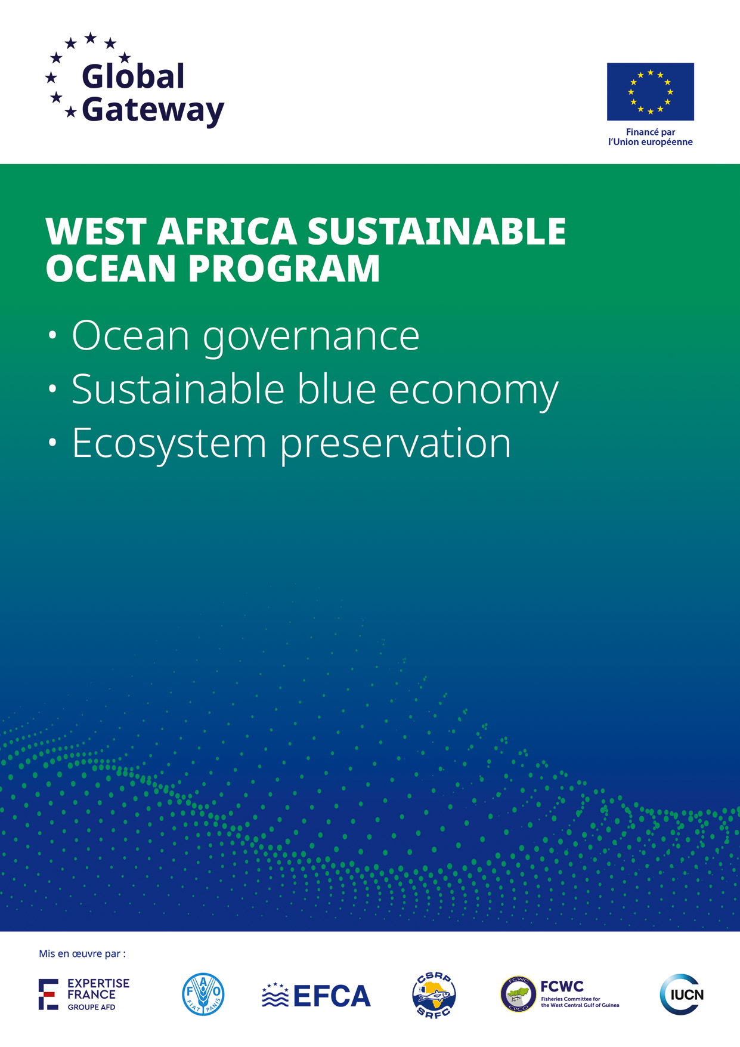

**WASOP launch event**

Recruitment of a local communication expert/event organizer

**Legal mentions and partners**

The WASOP program (West African Sustainable Ocean Program), financed by the European Union up to 59 million euros, aims to foster the integrated and sustainable management of marine and coastal resources in West Africa by supporting inclusive and competitive economic growth. Aligned with the African Union's Agenda 2063 and the European Union's Ocean Pact, the program promotes the sustainable blue economy as the driving force behind Africa's future. It adopts an integrated “Seascape Approach” centered on 3 complementary pillars: (i) ocean governance (ii) development of a sustainable blue economy (iii) preservation of marine and coastal ecosystems.

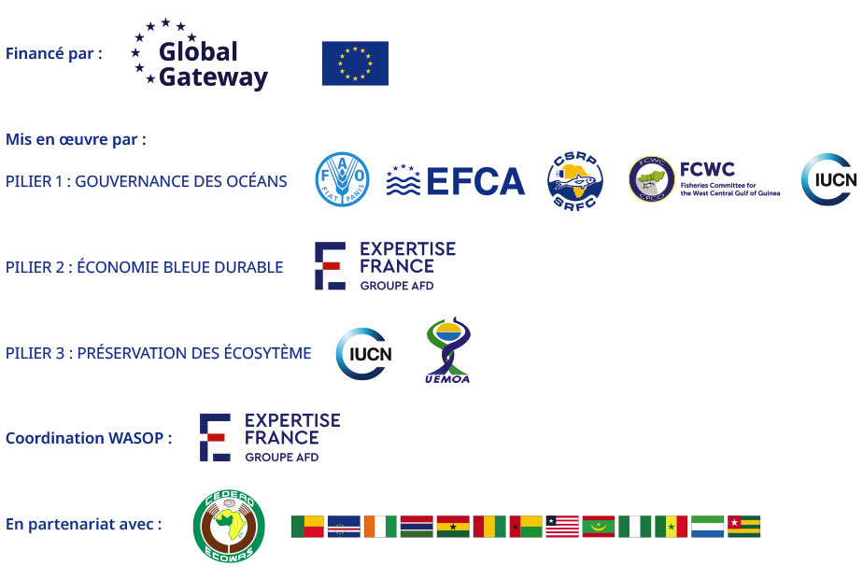

# TABLE OF CONTENT

TABLE OF CONTENT 2

I. Context 3

II. Objectives, deliverables & expected outcomes 4

1. Objectives 4

2. Activitiés and deliverables 4

1. Contribution to the overall coordination of communication aspects of the event 4

2. Steering and managing of service providers 5

3. Managing press relations 6

4. REXPECTED OUTCOMES 6

III. Duration and working approach 6

5. Duration 6

6. working approach 7

IV. Profile 7

a) Technical skills 7

b) Personal skills 7

c) Contextual knowledge (required) 8

# Context

**The West Africa Sustainable Ocean Program (WASOP)** aims to strengthen the protection of the marine environment and to promote a sustainable and integrated use of ocean resources in West Africa, fostering inclusive economic growth. It addresses the drivers of degradation of natural ocean resources and climate change, which exacerbate social, economic, and environmental tensions in the region. The WASOP project, funded with **€59 million by the European Union**, is structured around three pillars:

* **Pillar I – Ocean Governance**
* **Pillar II – Inclusive and Sustainable Blue Economy**
* **Pillar III – Ecosystem Protection and Restoration**

This programme is fully aligned with the priorities of the African Union, which has designated the blue economy as "Africa’s Future" in its Agenda 2063, underlining the importance of oceans for the continent’s socio-economic transformation. In West Africa, ocean resources are of strategic importance: they account for over 55% of regional GDP, with sectors such as fisheries, ports and coastal towns, and coastal areas hosting more than one-third of the region’s population.

However, there are a number of challenges that hinder the development of the blue economy’s full potential. Climate change, loss of biodiversity, overfishing and marine pollution are changing coastal ecosystems. Lack of capacity, access to finance, and adequate legal frameworks constrain investment in sustainable blue economy activities. Governance, regulatory bodies and enforcement of regional agreements remain underdeveloped, leaving critical marine protected areas unprotected, coastal areas and makes overexploitation of marine resources a growing concern. **The WASOP program contributes to overcoming these obstacles through an integrated action «seascape» articulated around 3 complementary pillars governance, sustainable blue economy and conservation.**

The program is implemented through a complementary partnership involving **Expertise France**, **FAO**, **EFCA**, the regional fisheries commissions **SRFC / FCWC**, and **IUCN**, in collaboration with **ECOWAS** and **13 West African coastal countries**: *Cape Verde, Mauritania, Senegal, The Gambia, Guinea, Guinea-Bissau, Liberia, Sierra Leone, Côte d'Ivoire, Ghana, Togo, Benin, and Nigeria*.

The 3 pillars are implemented **by complementary implementation operators** within a general action coordinated according to the «seascape» approach:

* **Expertise France** provides overall inter-pillar coordination of the WASOP programme and directly implements Pillar 2 to support a sustainable blue economy.
* **FAO-ICCAT**, EFCA **and the two sub-regional fisheries** sub commissions CSRP and CPCO **implement pillar 1 on governance, in particular of the fisheries sector.**
* IUCN **implements Pillar 3 on the** conservation and sustainable management of marine and coastal ecosystems.

This five-year regional programme is now transitioning into its launch phase, with the official inauguration scheduled for beginning of November 2025 in Cape Verde. The event will last for 3 days during the Ocean Week (week of November 3rd) and will reunite all stakeholders involved in the 3 pillars.

The launch event will be composed of:

* The first steering committee and the official launch of the programme covering all 3 pillars (including signature of Partnership agreements),
* The launch of the blue facility and the call for project proposals of pillar 2,
* The launch of a practitioners’ network,
* Concertation’s and site visits with the 13 beneficiary states of WASOP and WASOP stakeholders (pillar partners, ECOWAS, public investment banks, etc.).

**In this context, WASOP management is recruiting a local communication expert/event organiser**. This assignment will focus on the communication and visibility aspects of the workshop. The consultant will therefore work alongside the lead consultant and the international consultant on communication and visibility for the workshop.

# Objectives, deliverables & expected outcomes

## Objectives

### Main objective:

* Technical assistance to the « launch event task force » for the organisation of the event, especially regarding visibility and communication components.

### Specific objectives

* Support the « launch event task force » in steering, finding and managing key service providers for the organisation of the event,
* Participate in the coordination of communication activities under the lead of the event team leader and in collaboration with the international communication expert,
* Lead national press relations for the event and participate in regional and international press relations management.

## ACTIVITIES AND deliverables

### Contribution to the overall coordination of communication aspects of the event

Activities:

* Take note of existing documents on the launch event: ToRs, detailed agenda and framing of every session,
* Review and comment the communication plan for the event, including the calendar and foreseen content for social network publications,
* Advise the task force on recommendations regarding protocol issues and practices in Cabo Verde,
* Participate in some coordination meetings of the task force event,
* Participate to the 3 days launch event and support day to day coordination during the event,
* Advise the event task force on some logistic issues and provide recommendations upon locations.

Deliverables:

* Comments on the communication plan including social network publications plan (first week of September),
* Recommendations on protocol matters, logistic issues and event locations (end of August),
* Regular feedback during the organization of the event and day to day feedback during the event.

### Steering and managing of service providers

Activities:

* Draft the technical terms of references for a **service provider in charge of taking pictures and videos** [1]during the event (some of the pictures will need to be available “live” during the event itself to be used for posts on social networks), the ToRs will also have to include detailed directions (scenario) for a short video of the event, as well as some videotaped interviews.
* Manage the service provider in charge of photos and videos: briefing before the workshop, day to day coordination before, during and after the workshop, following up on the video editing.
* Review terms of references for a **service provider in charge of graphic design** who will produce communication supports such as event banner, kakemono, goodies for participants, event agenda and other document variations.
* Participate in managing the graphic designer, in collaboration with the French communication expert, and review graphic design deliverables.
* Find and manage a service provider for printing of communication supports (leaflet, goodies, reports, kakemono, etc.).
* Assist the project team in drafting terms of reference for other key service providers such as host for the event, travel agency, reception management including badging system and signage display in the conference centre/hotel), translation.
* Manage and coordinate the service provider for the reception management of the event.
* Assist in the overall coordination of the service providers mentioned above during the event.
* Advise the task force on finding the right service providers.

Deliverables:

* ToRs for the service provider in charge of pictures and videos including detailed directions for editing of an event video (15th of September),
* Comments on ToRs for the graphic designer and reviews on the deliverables (15th of September),
* Reviewed specifications for supports printing,
* Technical specifications for host (master of ceremony) and for reception services (hostess, signage, badging system),
* Recommendations and advice on logistics and management of services providers,
* List of pertinent service providers,
* Regular briefing notes on the management of service providers mentioned above, including briefing notes ahead of the event with a summary action to be taken by each provider during the event.

### Managing press relations

Activities:

* Draft a data base of journalists and/or media (priority to local media, and contributions to regional and international in collaboration with the French communication expert) and keep the data base up to date,
* Invite journalist and media and follow up in a tracking tool their interests and participation,
* Share contents with journalists and media about the event and the programme (content will be made available) and try to concretize their interests,
* Facilitate and organize interviews during the event,
* Make a quality and quantitative press review after the event.
* Ensure the coordination of press relations throughout the event.

Deliverables:

* Data base of national media and journalists and tracking tool of their participation/interests,
* E-mails sent to media and journalists,
* Writing feedback on the progress of press relations to the event task force,
* Day to day briefings during the event on press relations,
* Bookings for interview,
* Press review.

## EXPECTED OUTCOMES

* Smooth and effective management of service providers needed for the event,
* Efficient coordination and communication with the task force team leader and international communication expert,
* Quality press reviews.

# Duration and working approach

### Duration

The local communication expert is expected to start his mission at the end of August until the end of event. The consultant is expected to be in Mindelo for the event.

Total effort expected is 25 days.

### working approach

Service provision contract for an individual local expert, at unit prices based on daily fees.

**The consultant will work in collaboration with:**

* The task force team leader,
* The international communication expert,
* The WASOP project team,
* The service providers mentioned in the ToRs (non-exhaustive list below):
  + - Graphic designer,
    - Video and pictures,
    - Host (Master of ceremony),
    - Reception, signage and badging provider,
    - Hotel/Accommodation provider,
    - Printing provider,
    - Translation,
    - Technology/sound system provider.

**Strict compliance with the WASOP communication strategy and graphic charter and ensure its proper deployment by all partners and service providers.**

# Profile

### Technical skills

* Experience in organising national or regional wide event in Cabo Verde,
* Experience in managing a wide range of service providers involved in event organisation, and based in Cabo Verde,
* Experience in national press relations management in Cabo Verde, and if possible, in regional press relation management (would be an asset),
* Working experience for a donor or international financial institution would be an asset,
* Knowledge of thematic issues linked to sustainable development in Cabo Verde and if possible, in West Africa, as well as regional institution context (ECOWAS, regional organizations, and 13 WASOP countries).

### Personal skills

* Strong organizational and coordination skills.
* Highly adaptable, autonomous and rigorous.
* Excellent interpersonal skills and diplomacy, particularly in multicultural environments.
* Excellent ability to manager service providers in the context of an event.
* Proactive in finding solutions to problems.

### Contextual knowledge (required)

* Knowledge of challenges and context related to institutional communication in the development/aid sector,
* Excellent knowledge of the media landscape in Cabo Verde,
* Excellent knowledge of protocol practices in Cabo Verde,
* Excellent knowledge of the landscape of service providers required for an event in Cabo Verde,
* Total proficiency in Portuguese (fluent or mother tongue level), and ability to work in English,
* Good knowledge of the functioning of international cooperation projects and the requirements of donors, particularly the EU (actors, mechanisms, visibility requirements).

1. knowing that during the event there will be site visits as well as more traditional high-level conferences/working sessions