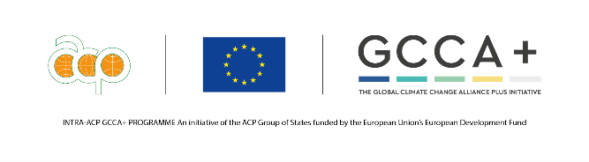
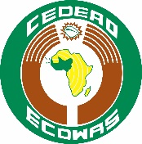
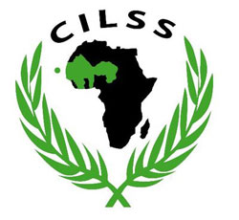
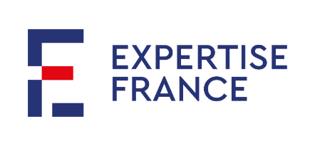

GLOBAL CLIMATE CHANGE ALLIANCE PLUS PROJECT –
WEST AFRICA (GCCA+ WA)

Terms of Reference
Climate expert
Responsible for the implementation of climate institutional capacity-building activities

June 2021
Recruitment carried out by Expertise France as part of the GCCA+ West Africa project

Funded by | 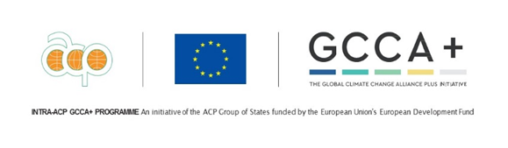
Implemented by | 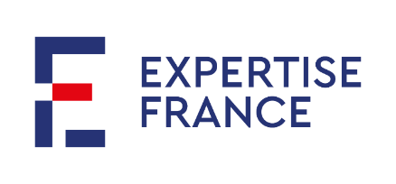
Under the political portage and for the benefit of | 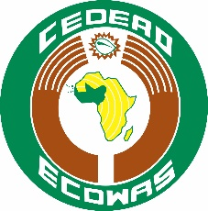
In partnership with | 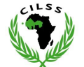

PROJECT PRESENTATION

Context and expected outcomes
The Global Climate Change Alliance (AMCC+ or GCCA+)

The Global Climate Change Alliance Plus (AMCC+ or GCCA+) is the second phase of an initiative of the same name launched by the European Commission (EC) in 2007, with a view to enhancing the dialogue and cooperation in the field of the fight against climate change between the European Union (EU) and the most vulnerable developing countries.
This second phase in particular aims to take into account the evolution of development issues and thereby contribute to the achievement of the Sustainable Development Goals defined by the United Nations and to the implementation of the Paris Agreement.
The GCCA+ initiative continues to support countries via two mutually reinforcing pillars: the political and technical dialogue and support for the implementation of national and regional climate change adaptation and mitigation policies, with a greater emphasis on the management of climate knowledge and communication on it.

The priorities for GCCA+ are as follows:

1- Build the scientific and technical capacities of the subregion in order to reduce vulnerability to climate change;
2- Promote the mainstreaming of aspects of climate change into development policies, strategies, programmes and projects at the subregional and national levels;
3- Support the development and implementation of subregional and national climate change adaptation programmes and projects.
The GCCA+ initiative breaks down into i) an “Overall’ component composed of programs set out by country under the supervision of the EU Local Delegations, and ii) an “Intra ACP” component under the coordination of the ACP Secretariat in Brussels. This component is itself divided into subregional components and Expertise France has been designated to manage the delegation of funds for West Africa.
The West Africa regional component
The GCCA+ West Africa project implemented by Expertise France with a 5-year budget of EUR 12.1m benefits from two regional bases: the political support for the project from ECOWAS, and a technical base with CILSS which will, in addition, be implementing part of the activities.
GCCA+ West Africa officially started on 1 January 2018 and began by a 12-month preparatory phase which aimed to lead to a common definition of the project outcomes and activities.
The 6 main project outcomes are as follows:

EO1. ECOWAS and its specialised agencies develop operational and institutional capacities that meet the needs of member countries (+ Chad and Mauritania) in the focus areas of GCCA+, in climate negotiations and in the implementation of the Paris Climate Agreement.
Indicative activities:
- Build the capacities of regional institutions on the climate and, in particular, on the Paris Agreement,
- Build the capacities of countries and regional institutions on international climate negotiations.

EO2. The climate change strategies and priorities – regional (ECOWAS) and national (member countries +2) – for the implementation of the Paris Climate Agreement in member countries are enhanced and their implementation is supported.
Indicative activities:
- Support capacities to consolidate and monitor the implementation of the Paris Agreement at regional level,
- Support the implementation of national contributions.

EO3. Pilot adaptation projects, including solutions based on an ecosystem approach, which have already been tested and implemented in ECOWAS countries and serve as a reference, are scaled up.
Indicative activities: This outcome will mainly be achieved via the launch of calls for projects.

EO4. Regional organisations and ECOWAS member countries step up the strategic dialogue, build their negotiation capacities, share information and skills, and the outcomes and knowledge on climate action.
Indicative activities:
- Continue the analysis of the climate, its impacts, the vulnerability of agro-pastoral systems and the production of hydro-climate information,
- Capitalise on and share good practices and innovative technologies on climate change adaptation and mitigation in West Africa.

EO5. The capacities of technical institutes, universities and regional centres to provide training services, research and support for innovation in sectors related to climate change adaptation and mitigation are strengthened.
Indicative activities:
- Set up diploma-based training in the field of climate change,
- Develop e-learning dynamics on these subjects in the region.

EO6. With the prospect of future support through climate finance and investments, innovative approaches involving the public and private sectors for climate and economic resilience are prepared and tested.
Indicative activities:
- Facilitate access to financing for project initiators by building project engineering capacities and knowledge on the appraisal of the various funds.

Find out more about the project news: https://bit.ly/GCCAPlusWA

Implementation structure
The project is coordinated from Lomé (Togo). The Project Coordination Unit (PCU) is based at the Regional Agency for Agriculture and Food (RAAF) and is responsible for:
- Proposing and managing the strategic orientation and activities with a partnership approach for validation by the Steering Committee;
- Managing the implementation of the strategic orientations validated by the Steering Committee;
- Implementing part of the activities and, in particular, coordinating the call for project proposals processes and the management and implementation of pilot projects;
- Mobilising actors and partners for strategic objectives;
- Coordinating the technical and financial reporting of the project;
- Conducting the contractual monitoring of the grant allocated to CILSS and RAAF;
- Promoting and harmonising good practices and procedures within the project;
- Managing the monitoring-evaluation and capitalisation at the project level;
- Guiding and handling the communication and dissemination of the project actions and outcomes.

It is composed of:
- A coordinator,
- A Climate and Paris Agreement Institutional capacity building officer, responsible for components 1 and 2,
- A pilot project officer, responsible for component 3
- A climate finance expert, responsible for component 6
- A monitoring-evaluation/capitalization manager,
- A communication manager and a communication officer.
- An administrative and financial manager
- A project assistant.

The project coordination unit works directly with a technical assistance that provides expertise to all project components (framing, technical supervision, quality control, etc.).
Part of the activities are directly implemented by CILSS. The outcomes of these activities will be subject to a consolidation by the PCU to provide an overall report on the project implementation. Furthermore, RAAF is responsible for the financial and administrative management of the activities related to the regional workshops and/or training, and related to the operation of the PCU. It has also been entrusted with a grant in this respect.
The PCU works closely with the RAAF, the CILSS, the ECOWAS Commission and the EF headquarters.
The activity manager in charge of institutional capacity building for climate and Paris Agreement, currently in charge of components 1 and 2, will leave the project in September. The objective of these ToR is to frame the recruitment of this position. Given the project schedule, an expanded scope is proposed for this position.

OBJECTIVES OF THE MISSION
Under the responsibility and supervision of the project coordinator based in Lomé, the climate expert will be responsible for carrying out all activities necessary to achieve results 1 and 2. He/she will consolidate and continue the work already done since the beginning of the project in the framework of these components. Given the cross-cutting nature of climate expertise and institutional capacity building in the project, the person in charge will have to work in close collaboration with the entire PCU and will have to promote synergies and collaborations with all the project's results. As such, he/she will have to participate in the implementation of the project's capitalization strategy.

The objectives of the mission can be detailed as follows:
- To pilot and implement all the activities necessary to achieve results 1 and 2 of the GCCA+ WA project, among others:
- Support the completion of the ECOWAS Regional Climate Strategy (RCS) development process and its communication on the international and West African scene
- Support the operationalization of the ECOWAS climate coordination mechanisms for which the project participated in the design work
  - RCS
  - Regional Support Group for International Climate Negotiations (RAG CLIN)
  - Interdepartmental Environment Committee (CIDE)
- Leading the support/capitalization of the implementation of NDCs in WA: support and capitalization of pilot supports, leading the capitalization review of NDCs in West Africa, etc.
- Provide technical expertise on climate within the other components of the project and notably ensure the link with the RCS
- Participate actively in the overall capitalization of the project
The activities are implemented, among others, through the mobilization of technical experts from the GCCA+ WA project's Technical Assistance (TA). The manager will therefore be in charge of this coordination for the activities he/she monitors. He/she will also be responsible for coordinating technical working relations with the project's focal points within ECOWAS.

DESCRIPTION OF TASKS
The Climate and Paris Agreement institutional capacity building activity officer will globally implement all the activities of the project action sheet and the work plan for regional/national institutional capacity building on the integration of climate change into public policies. Among these activities can be noted the following non-exhaustive activities.

Coordinate the implementation of RAG CLIN
Additional Background on RAG CLIN
The ECOWAS Commission is in the process of establishing a Regional Support Group for International Climate Negotiations (RAG CLIN) to strengthen its member states and its proactivity in the international negotiations taking place under the United Nations Framework Convention on Climate Change (UNFCCC) and more specifically the Paris Agreement.
RAG CLIN is established as a technical advisory body to the ECOWAS Commission, in order to strengthen the defense of common West African interests within the UNFCCC Africa Group, and to allow for a better coordination of common regional positions on issues within ECOWAS' areas of competence.
Its specific objectives are as follows:
- Analyze the issues at stake in the Conferences of the Parties and other international climate negotiation meetings and propose elements for a common position;
- Assist the ECOWAS Commission during informal consultations and side events of the Conference of the Parties (COP) and relevant meetings of related agreements;
- Strengthen the capacity of national institutions and representatives of ECOWAS Member States for the preparation/review of draft decisions and support them during negotiations at the COP and relevant meetings;
- Stimulate and intensify a strategic dialogue within West Africa on climate negotiations.

The EO1/EO2 manager will be in charge of steering this activity within the PCU, and more specifically of:
- Coordinate the progress of the RAG CLIN work throughout the project and supervise the framing of the RAG CLIN annual work programs;
- Support ECOWAS in the logistical and technical organization of the RAG CLIN working meetings;
- Accompany ECOWAS in its role of coordination/supervision of the work of RAG CLIN and organize the mobilization of CILSS;
- To participate in the working meetings of the RAG CLIN and the quality control of the deliverables produced by the RAG CLIN;
- Co-organize the regional workshops of preparation to the COPs and accompany the RAG CLIN and the ECOWAS to the COPs;
- Follow the contracting of the experts who will compose the first promotion, the invoicing and the organization of their missions (travel).

Support the development and implementation process of the ECOWAS Regional Climate Strategy (RCS)
The project supports ECOWAS in the development of its regional climate strategy. The latest working draft of the RSC is to be delivered to the Commission in mid-September by the GCCA+ WA project before being processed through the formal ECOWAS adoption process. The Activity Manager will therefore be responsible for monitoring the finalization of the strategy and the appraisal process, and then for planning and implementing the project's work program to support its implementation in 2022.
This work includes defining and monitoring the implementation of the Commission's capacity building activities, including the Interdepartmental Committee on the Environment (ICDE).
More specifically, the person in charge will be responsible for:
- Coordinate ongoing services and teamwork among technical experts involved in the development and implementation of the regional climate strategy and contribute technically to project outputs;
- Coordinate working relations with ECOWAS focal points within the DAERE, which constitutes the strategy's restricted technical monitoring committee;
- Assist ECOWAS in the process of appraisal of the RCS and in its participation in the COP26 to present it;
- Ensure the good visibility of the RSC in line with the communication plan defined and participate in the implementation of this communication plan on the process;
- Assist the DAERE in its role as a select committee for technical monitoring of the strategy (end of development and then implementation phase) and more specifically in its role as secretariat of the Interdepartmental Committee on the Environment (CIDE): framing of meetings, support for report writing, etc.
- Plan activities with stakeholders to support the implementation of the CRS in 2022;
- Supervise and monitor the work of the experts mobilized by the project;
- Ensure quality control of the deliverables produced;
- Ensure operational reporting of activities.

Other significant activities of the position.
- Monitor-implement-capitalize the pilot support provided by the project to 4 countries (Liberia, Sierra Leone, Guinea Bissau, Togo) as part of the revision or implementation of their NDCs.
- Participate in the strategic framing and definition of the work program for the participation of the project and ECOWAS in the COPs: draft the terms of reference and concept notes for events and pavilions, organize the planning and events, participate in the visibility of the project during the COP.
- Lead the editorial committee of the project capitalization magazine entitled "Stories of NDCs in West Africa” alongside the communication officer and the TA: definition of topics, production/proofreading and technical review of articles produced, dissemination and promotion of articles.
- Participate in the overall implementation of the project activities by providing climate expertise / and institutional climate capacity building.
- Participate in the implementation of the project's communication and capitalization strategies: notably
- by capitalizing on and bringing to life the products of past activities (ECOWAS guide on the implementation of the Paris Agreement, pilot NDCs support in 4 countries etc.),
- by participating in the writing of the content of web articles or other communication products related to EO1 and EO2,
- actively participating in the capitalization and communication of other project activities by focusing on climate and institutional strengthening issues.
- Promote synergies with other initiatives and programs underway in the region.
- Participate in the coordination, representation and monitoring-evaluation of the project.
- Participate in budget planning and financial reporting exercises for EO1 and EO2 with the RAF.
- Carry out the archiving of data under his responsibility.

ORGANIZATION & LOCATION
The position is based in Lomé in the offices of the project coordination unit hosted by the RAAF. Health conditions permitting, the position will involve numerous missions to the ECOWAS/CILSS zone, particularly to Abuja where the ECOWAS Commission is based.

EXPERIENCES AND QUALIFICATIONS

Qualifications
- Have an advanced university degree (Master's) in political science, international relations, environmental studies, agronomy, climate change and/or related disciplines.

Experiences
- At least 10 years of professional experience in the sector(s) related to the assignment: environment, climate change, international cooperation and institutional capacity building.
- At least 10 years of experience working with government institutions in the development/implementation of public climate policy and institutional capacity building in West Africa (experience working with ECOWAS and/or CILSS would be an asset);
- At least 7 years of experience in management/operation of large/complex cooperation projects with the implementation and reporting of a program of activities;
- At least 7 years of experience in multi-stakeholder (public, private) facilitation/cooperation
- Experience working with Climate change networks in West Africa
- Successful experiences in mainstreaming climate in several priority sectors for West African countries
- Three (3) experiences working at the regional level in West Africa.

Skills
- Have a very good knowledge of the objectives and issues of the Paris Agreement and the Nationally Determined Contributions (NDCs) mechanism;
- Have a good knowledge of the current issues of negotiations under the Paris Agreement;
- Have a good understanding of the regional institutional context (ECOWAS policies, CILSS, in particular) and a very good knowledge of the issues related to climate change for the region;
- Analytical skills and ability to make proposals on the conduct of activities
- Good teamwork skills, particularly within multicultural teams
- Strong capacity for adaptation and diplomacy;
- Ability to write clear and precise activity reports
- Excellent written and oral skills in English and French, with Portuguese an asset
- Have a strong work capacity, especially with fixed/urgent deadlines
- Demonstrate rigor and organization to implement a work plan in a timely manner and ensure all required consultations.

CONDITIONS
Position: Fixed-term employment contract
Start date: As soon as possible
End date: December 2022

APPLICATION FILE
- A CV (EU format)
- A Cover letter
- 3 references that can be contacted

