Candidature form
Individual expertise
PLEASE NOTE: use of this form to reply to the invitation to tender referred to in point II is mandatory. If this form is not submitted the candidature will be rejected.
I – Identification of the contracting authority.
Expertise France (EPIC), 73 rue de Vaugirard, 75006 PARIS.
II – Purpose of the invitation to tender
The present invitation to tender relates to “Full Web Development Expert”.
III – Identification of the candidate
[State the commercial name and corporate designation, the status (self-employed, individual company, SA [joint-stock company], SARL [limited liability company], EURL [single-person limited company], association, public body, etc.), the addresses of its establishment and its registered office (if this is different from that of the establishment), its email address, its telephone and fax numbers, and its SIRET number; failing this, a European or international identification number, or one specific to the candidate's country of origin.]
The candidate offer(s) itself/themselves alone as an individual candidate with its/their own legal personality (self-employed or single-person company status).
The expert's candidature is submitted by a legal entity, its employer or an umbrella company (firm, association, company, public/para-public organisation, etc.)
IV – Purpose of the candidature
The present candidature is presented in connection with the invitation to tender “Full Web Development Expert”.
V – Information on registration in a professional register
The candidate must produce proof that it is registered in a professional register (e.g.: Kbis extract for a company established in France or equivalent).
VI – Information relating to the candidate's economic and financial capacity
Not applicable
VII – Information relating to the candidate's references
The technical and professional capacity of the individual expert shall be assessed on the basis of their training and their professional experience in respect of Full Stack web application development.
The candidate shall complete and provide their CV using the template in the appendix to the present candidature form.
VIII – Proof that fiscal and social security obligations have been met
The candidate must prove that it has met its fiscal and social obligations, by providing all means of proof (latest available URSSAF or equivalent certificate, latest available fiscal or equivalent certificate, etc.).
IX – Solemn declaration
The candidate must complete, date and sign the declaration of honour relating to the exclusion criteria and to the lack of a conflict of interest contained in an Appendix to the present form.
X – Third-party identity form and Bank Account Identifier
The candidate must complete, date and sign the "third-party identity form" contained in an Appendix, and must in all cases attach a Bank Account Identifier (RIB).
In some countries banks do not issue Bank Account Identifiers ; in this case the candidate must also have the "Third-party identity form" signed by the banking establishment.
SIGNATURE

Signature of the individual Expert candidate or, if applicable, the person authorised to engage the legal entity candidate.
Surname:  First name:  Position: | I declare that I submit my candidature in connection with the invitation to tender referred to in point II above.  Date:  Signature:

APPENDIX 1:
DECLARATION OF HONOUR ON EXCLUSION CRITERIA AND ABSENCE OF CONFLICT OF INTEREST (INDIVIDUAL EXPERTISE).
[Complete or delete the greyed-out parts in italics between square brackets].

Purpose of contract: “Full Web Development Expert”.

[The] undersigned (name of the signatory of the present form) :
- acting in its own name (in the case of an individual expert candidature with a legal personality)
or
- acting in a capacity of representative of the following legal entity :
full official name:
official legal form:
full official address:
- declares that it is not in a situation mentioned in articles 45 and 48 of Order 2015-899 of 23 July 2015 and in particular in a situation whereby it :
- is bankrupt or being wound up, is having its affairs administered by the courts, has entered into an arrangement with creditors, has suspended business activities, is the subject of proceedings concerning those matters, or is in any analogous situation arising from a similar procedure provided for in national legislation or regulations ;
- has been convicted of an offence concerning its professional conduct by a judgment of a competent authority of a Member State which has the force of res judicata ;
- has been guilty of grave professional misconduct recorded by any means which the contracting authority is able to prove, including by a decision of the European Investment Bank or an international organisation ;
- has not met its obligations relating to the payment of social security contributions or the payment of taxes in accordance with the legal provisions of the country in which it is established or with those of the country of the contracting authority or those of the country where the contract is to be performed;
- has been the subject of a judgment which has the force of res judicata for fraud, corruption, involvement in a criminal organisation, money laundering or any other illegal activity, when the said illegal activity is detrimental to the financial interests of Expertise France or of the French State ;
- is subject to an administrative sanction due to its having made false declarations when supplying the information required by the awarding authority for its participation in a procedure of granting of a subsidy or of signing another contract, or has not provided this information, or due to its having been declared to have seriously failed to perform its obligations under contracts or in respect of subsidies financed by the budget of Expertise France or the French State.
- declares that the natural persons having the power of representation, decision or control over the above-mentioned legal entity are not in the situation referred to in points b) or e) above ;
- declares that it :
g) is not in a situation of conflict of interest with respect to the contract ; a conflict of interest can arise, in particular, from economic interests, from political or national affinities, from family ties or friendships, or from all other types of common relations or interests ;
h) shall make known, without delay, to the awarding authority, all situations constituting a conflict of interests, or which may lead to a conflict of interests ;
i) has not granted, sought, or sought to obtain or accepted, and undertakes not to grant, search, or seek to obtain or accept, any benefit, financial or in kind, for or from any natural person or legal entity when this benefit constitutes an illegal practice or involves corruption, directly or indirectly, in that it amounts to a gratification or reward relating to the award of the contract ;
j) has provided accurate, honest and complete information to the awarding authority under the present contract-award procedure ;
- accepts that it may be subject to judicial, administrative and financial sanctions if it is established that false declarations have been made, or that false information has been supplied.
If the contract is awarded, the following information must be supplied on request, within the term determined by the awarding authority :
In the cases mentioned in points a), b) and e) a recent extract from the criminal records office is required, or failing this a recent equivalent document, issued by a legal or administrative authority of the country of origin or of provenance, showing that the requirements concerned have been met.

In respect of the situations described in points a), b), d) and e), when a document referred to in the above two paragraphs is not issued in the country in question it can be replaced by an affidavit or, failing this, a declaration of honour, made by the person concerned before a judicial or administrative authority, a notary or a qualified professional organisation of the country of origin or of provenance.
If the tenderer is a legal entity, information concerning the natural persons with power of representation, decision or control over this legal entity must be provided only at the request of the awarding authority.
- declare that I have examined the provisions of the present declaration, and undertake to comply with them throughout the contract-award procedure.

Signature of a person authorised to engage the legal entity candidate
This insert must be signed in the case of a candidature submitted by a legal entity (i.e.: engineering firm or consultancy, or umbrella firm) ; in the case of freelance administration the expert candidate must sign this declaration.
Surname:  First name: | Date:  Signature:
Signature of the Expert candidate
Surname:  First name: | Date:  Signature:

EXPERT CURRICULUM VITAE (5 pages maximum):
___________________________________________________

1. Surname :_______________
2. First name :______________
3. Date of birth :______________
4. Nationality :_____________
5. Language(s) spoken :(Level of competence graded 1 to 5; where 5 is the highest):
Language | Understood | Spoken | Written

6. Training :
Institution [Start date - End date] | Qualification(s) obtained:

7. Key competences related to the sector :

Profile requested in the TdR | Expert's experience

8. Professional experience - Invitations to tender
Date | Country | Company, sponsor and reference person | Position | Description of assignments undertaken (key qualifications/field of expertise)

9. References (Surname, first name, position, structure, email address)

Signature of the expert

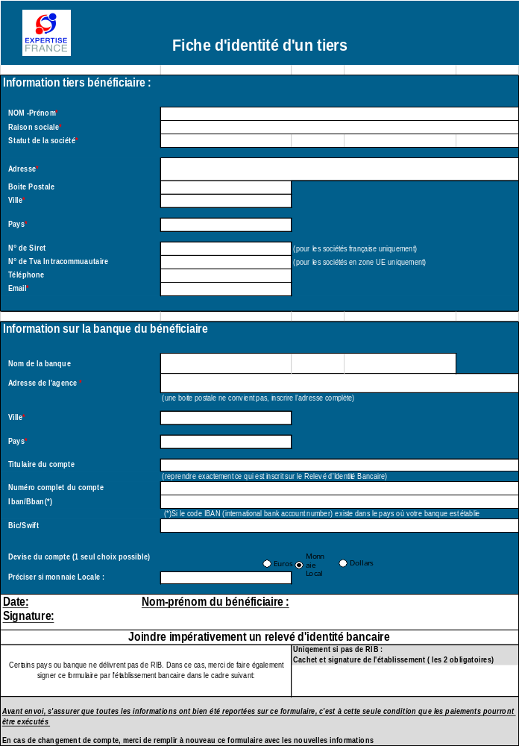

Recent certificates or letters, issued by the competent authorities of the State in question, are required. These documents must give proof of payment of all taxes, duties and social security contributions which the tenderer is liable to pay, including VAT, income tax (natural persons only), corporation tax (corporate entities only) and social charges.
Namely, business leaders, members of the managing or supervisory bodies, and natural persons holding, on an individual basis, the majority of the shares.
If the tenderer is a legal entity, and if the national law of the country in which it is established cannot provide such documentation for legal entities, these documents are demanded for the natural persons, such as the business leaders or all persons having power of representation, decision or control over the tenderer.

